President

Dr. Georgi Nikolov
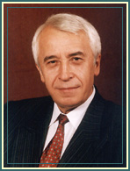
Born on April 2, 1945 in Babovo, district Ruse. He graduated from the Economic Academy "D. Tzenov" in Svishtov, Major Finance and credit.
He is Doctor in Economics. He has been elected for Member of Parliament:
· to the Grand National Assembly – member and secretary of the Economic committee
· in the 36th National Assembly – vice-chair of the Budget and Finance committee and member of the Economic committee
· in the 37th National Assembly – chair of the Budget and Finance committee.
He is a lecturer at the Economic Academy "D. A. Tzenov" in Svishtov since 1970. He has published in the field of audit, finance, statistics, economics of construction, economy effectiveness and other. He reads French and Russian.
The National Assembly elected him President of the National Audit Office of the Republic of Bulgaria on October 13, 1995.

Members
Bojidar Vlahov
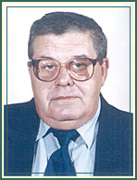
Born on December 22, 1941 in Radomir. He graduated from the Higher Economic University, Sofia, (at present National and World Economics University), Major Industrial economics.
He worked as specialist and chief specialist in the Planning State Committee, chief specialist in the Head Department for prices at the Ministry of finance, chief director of "Social infrastructure" in the Ministry of economics and planning, chair of the Board of directors of "Metal constructions" Plc. He has published in Bulgarian and foreign issues some articles and elaborations in the field of social infrastructure, in modeling the development of the service area and on the control activity. He reads German and Russian.
The National Assembly elected him Member of the National Audit Office on November 24, 1995.
Dimitar Chapanov
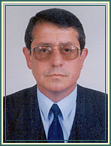
Born on July 24, 1954 in Botevgrad. He graduated from the Economic Academy "D. A. Tzenov" – Svishtov, subject "Accountancy".
He worked in the Ministry of finance as specialist and chief specialist on methodology of the accountancy and on national balance of currency, chief specialist in the Ministry of economics and planning, department "Economic mechanisms". In 1989 - 1990 he was deputy general director of state company "Sokol". Afterwards he worked as taxation methodologist at the Sofia Tax Authority. He reads Russian.
The National Assembly elected him Member of the National Audit Office on November 24,1995.
Hristina Simeonova
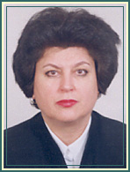
Born on August 10, 1953. She graduated from the Economic Academy ‘D.A.Tzenov’- Svishtov, Major Finance and Credit. In 1974 she was employed at the Ministry of Finance.
She worked in different departments and divisions e.g. Control of Securities, State Revenues, Financial Policy, Financial Standards for Economic Activity. She occupied the position of Chief Expert at the Main Tax Administration since 1991. She specialized in Accounting and Taxation in Austria and Germany.
She has publications in the field of Accounting and Taxation. She speaks English and Russian.
The National Assembly elected her Member of the National Audit Office on November 24, 1995.
Prof. Dr. Ivan Doushanov
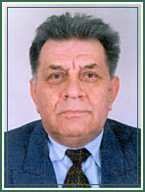
Born on July 27, 1928 in Kaltinetz, Veliko Tarnovo district. He graduated from the Higher Economic University, Sofia, ( at present National and World Economics University (NWEU) , Major Accountancy and control, and the Sofia University St. Kliment Ohridski, Major Law. He is doctor in Economics. He is chair of the Accountant’s association in Bulgaria, Editor-in-chief of the magazine "Bulgarian accountant", honorary member of the Accountant’s association in Poland.
He worked as deputy-chief of the Department "State financial control" and head of department "Accountability and legal and accountancy experts’ report" in the Ministry of finance. To 1995 he was general director of the Post-graduate Vocational Training Institute at the NWEU. He made a speciality of accountancy in the Petersburg Institute for Finance and Economics and in the University of Economics in Krakow (Poland). He is licensee for evaluator of whole enterprises by the Tampa University (USA). He is author of over 250 publications in the field of accountancy, the internal and inspection financial control, the financial and economic experts’ reports. He has proficiency in German and Russian. He was head of chair "Accounting and economic analysis" at the NWEU and deputy rector for the training activity at the same university.
The National Assembly elected him Member of the National Audit Office on November 24, 1995.
Jivka Dimitrova
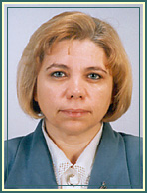
Born on August 15, 1957 in Harmanli. She graduated from the Economic Academy "D. A. Tzenov" – Svishtov, Major National economy management and planning.
She worked as economist in the Scientific and production works on robotics "Beroe" – Stara Zagora, and in the Electric truck works "Shesti sepremvri" - Sofia. Since 1996 to 1988 she has been chief specialist and secretary of the Production commission in the Municipal administration "Nadezhda". Since the establishment of the tax administration in 1991 she worked as chief inspector in the tax office in the Municipal administration "Nadezhda", and since 1994 – as head of the office. She reads French and Russian.
The National Assembly elected her Member of the National Audit Office on November 24, 1995.
Kadir Kadir
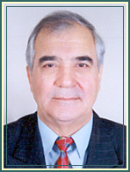
Born on October 5, 1940 in Zavet, Razgrad District. He graduated from the Sofia University St. Kliment Ohridsky, Major Law.
He worked as Chief Legal Adviser at the Construction and Machine Building Administration in Pleven. Chairperson of the Labour and Social Insurance Committee and Member of the Legislative Committee at the VII-th Grand National Assembly. Deputy Chairperson of the Central Election Committee.
The National Assembly elected him Member of the National Audit Office on November 24, 1995.
Katina Krasteva-Kaleva (1998-2005)
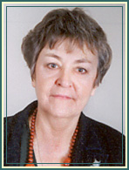
Born in 1939 in Enina, Kazanlak Region. She graduated from the Sofia University St. Kliment Ohridsky, Major Law.
She worked as judge and Vice President of Sofia Regional Court and Sofia City Court. In 1990 the National Assembly elected her Member of the Supreme Court of Bulgaria and later on Member of the Supreme Cassation Court.
She is married and has one child.
The National Assembly elected her Member of the National Audit Office on February 24, 1999.

Kolio Bounkov
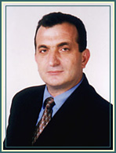

Born on December 25, 1954 in Huhla, Kardjali District. He graduated from the Sofia University St. Kliment Ohridsky, Major Law.
He worked at: the Legal Department of the Ministry of Education; the State Financial Control Agency; Main Administration of State Legal Advisers at the Ministry of Finance.
During the period 1992-1993 he was Administrative Manager at the Bulgarian Embassy in Warsaw. Since September 1993 he occupied the position of Head of Legal Department of the Tax Administration at the Ministry of Finance.
He speaks Polish and Russian.
The National Assembly elected him Member of the National Audit Office on November 24, 1995.
Kiril Kolchev
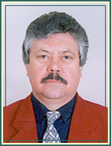
Born on March 12, 1950 in Kardjali. He graduated from the Economic Academy ‘D.A.Tzenov’, Svishtov, Major Accounting. He took a Post-graduate Degree at the National and World Economic University in Sofia, 1980.
He worked as accountant at the Lead-Zinc Works, Kardjali. Since 1978 he was Expert and afterwards Chief Expert at the State Financial Control Department at the Ministry of Finance. In 1992 he won a competition and became Head of the Territorial State Financial Control Directorate, Sofia District. In 1988 he specialized in Control of the Expenditure of Budgetary Institutions. Speaks Russian.
The National Assembly elected him Member of the National Audit Office on November 24, 1995.

Nadejda Sandolova
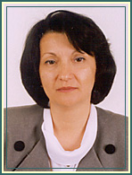
Born on April 17, 1956 in Sofia. She graduated from the Higher Economic University, Sofia, (at present National and World Economics University) , Major Planning, Management and Balance.
She worked as a lecturer at the Economic Faculty of Sofia University St. Kliment Ohridsky. She has more than 30 publications in the field of economic reforms in Bulgaria.
In the period 1991-1995 she successively occupied the position of Head of Department International Financial Institutions at the Ministry of Industry; Member of the Board of Directors of Sofia Bank; Chairperson of the Board of Directors of FILTEX-Plovdiv JSC.
She specialized in Banking, Financial Management and Stock Exchange Transactions at the Central Bank, Munich, Germany and in the USA.
Speaks German, English and Russian.
Married and has 2 children.
The National Assembly elected her Member of the National Audit Office on November 24, 1995.

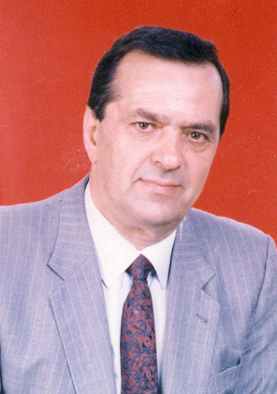
Yovcho Rusev (1995-1998)

