Bulgarian National Audit Office (2005-2011)

President

Prof. Valeriy Dimitrov

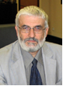
Born on June 2, 1954 in Sofia. He graduated in Law. Professor in Administrative Law, Associate Professor in Financial Law and Doctor in Law. In 1980-1984 is Lawyer in "Road Construction" company, Sofia. Since 1984 until now he is a professor in financial, banking and securities in the University of National and World Economy. From 1991 to 2001 he is a legal adviser to the Governor and the Governing Board of the Bulgarian National Bank (BNB). From 1996 to 2001 he is a representative of BNB in the Board of Directors of the Central Depositary AD.
Elected Member of the 39th National Assembly where he is a Chairperson of the Economic Policy Committee, Member of the Legal Affairs Committee and of the Budget and Finance Committee.
He speaks English and Russian. Author of books, studies and articles in the field of banking, securities, financial and administrative law.
Married with two children.
The National Assembly elected him a President of the National Audit Office of the Republic of Bulgaria on April 7, 2005.

Members

Erdzhan Alkova
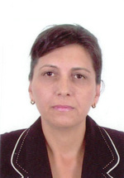
Born on September 27, 1965 in Veliko Tarnovo.
She graduated in Accountancy and control from the Economic Academy "D.A.Tzenov" in Svishtov and in Law from the Veliko Tarnovo University St.st.Cyrill and Methody. Master of Inspectoral financial control and Law.
Since 1985 she is successively accountant in DSK bank, cashier-accountant in Bulgarian Red Cross, financial expert in the Public Internal Financial Control Agency, vice-mayor of the municipality of Veliko Tarnovo. She specialized in the field of local self-government, territorial settlement policy, women’s rights in USA, Netherlands, Germany, Italy, Turkey.
She speaks Turkish and English.
The National Assembly elected her Member of the National Audit Office of the Republic of Bulgaria on April 13, 2005.

Eugenia Penkova
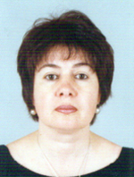
Born on February 6, 1959 in Haskovo.
Graduated in Finance and credit from the University of National and World Economy /UNWE/, Sofia.
Since 1986 she is a lecturer in the Management of the Social activities department in the UNWE.
From 2000 to 2005 she has been successively head and vice-dean of the Infrastructure economy department in UNWE. Associate professorq doctor of Economy.
Since 2002 she has been president of the Post-privatization control agency.
She specialized in Germany, Russia, Greece, Hungary, UK and Netherlands. She took part in 16 international projects to PHARE, TEMPUS, Leonardo da Vinci, MATRA and other programs.
She has more than 30 scientific publications in the field of public finance.
She speaks Russian and English.
The National Assembly elected her Member of the National Audit Office of the Republic of Bulgaria on April 13, 2005.

Goritsa Grancharova
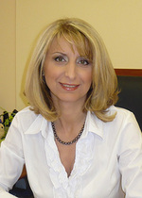
Born on April 9, 1966 in Razlog, Blagoevgrad District.
She graduated from the Economic Academy "D.A.Tzenov" in Svishtov, Major "Accountancy and control".
Her professional career has been for many years in the field of banking and finances. From 2000 to April 2004 she is Manager in the "Economic and Investment bank", Sofia. She was manager in TS Bank – in the town of Bansko, deputy of the chief accountant and expert in "Bulgargas", Sofia and the State Insurance Institute, Razlog.
From May 2004 to April 2005 she is chief expert in the National Income Agency.
The National Assembly elected her Member of the National Audit Office of the Republic of Bulgaria on April 13, 2005.

Hyusein Chaush
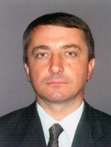
Born on November 29,1963 in Bradvari, Silistra District.
He graduated from the Higher Economic Institute and Varna Free University in "Accountancy" and "Political sciences" in the town of Varna. Major in Economy and Foreign Affairs. From 1988 to 2001 he is successively Chief Accountant at Machinery Construction Works, Vice-Mayor and President of the Municipal Council in the town of Dulovo.
Since 2001 he is a Member of Parliament. In the 39th National Assembly he is Vice-Chair of the Culture Committee, Member of the Budget and Finance Committee, Combating Corruption Committee and ad-hoc committees.
He speaks Turkish, Russian and English.
Married with a child.
The National Assembly elected him Member of the National Audit Office of the Republic of Bulgaria on April 13, 2005.

Kadir Kadir (2005-2009)
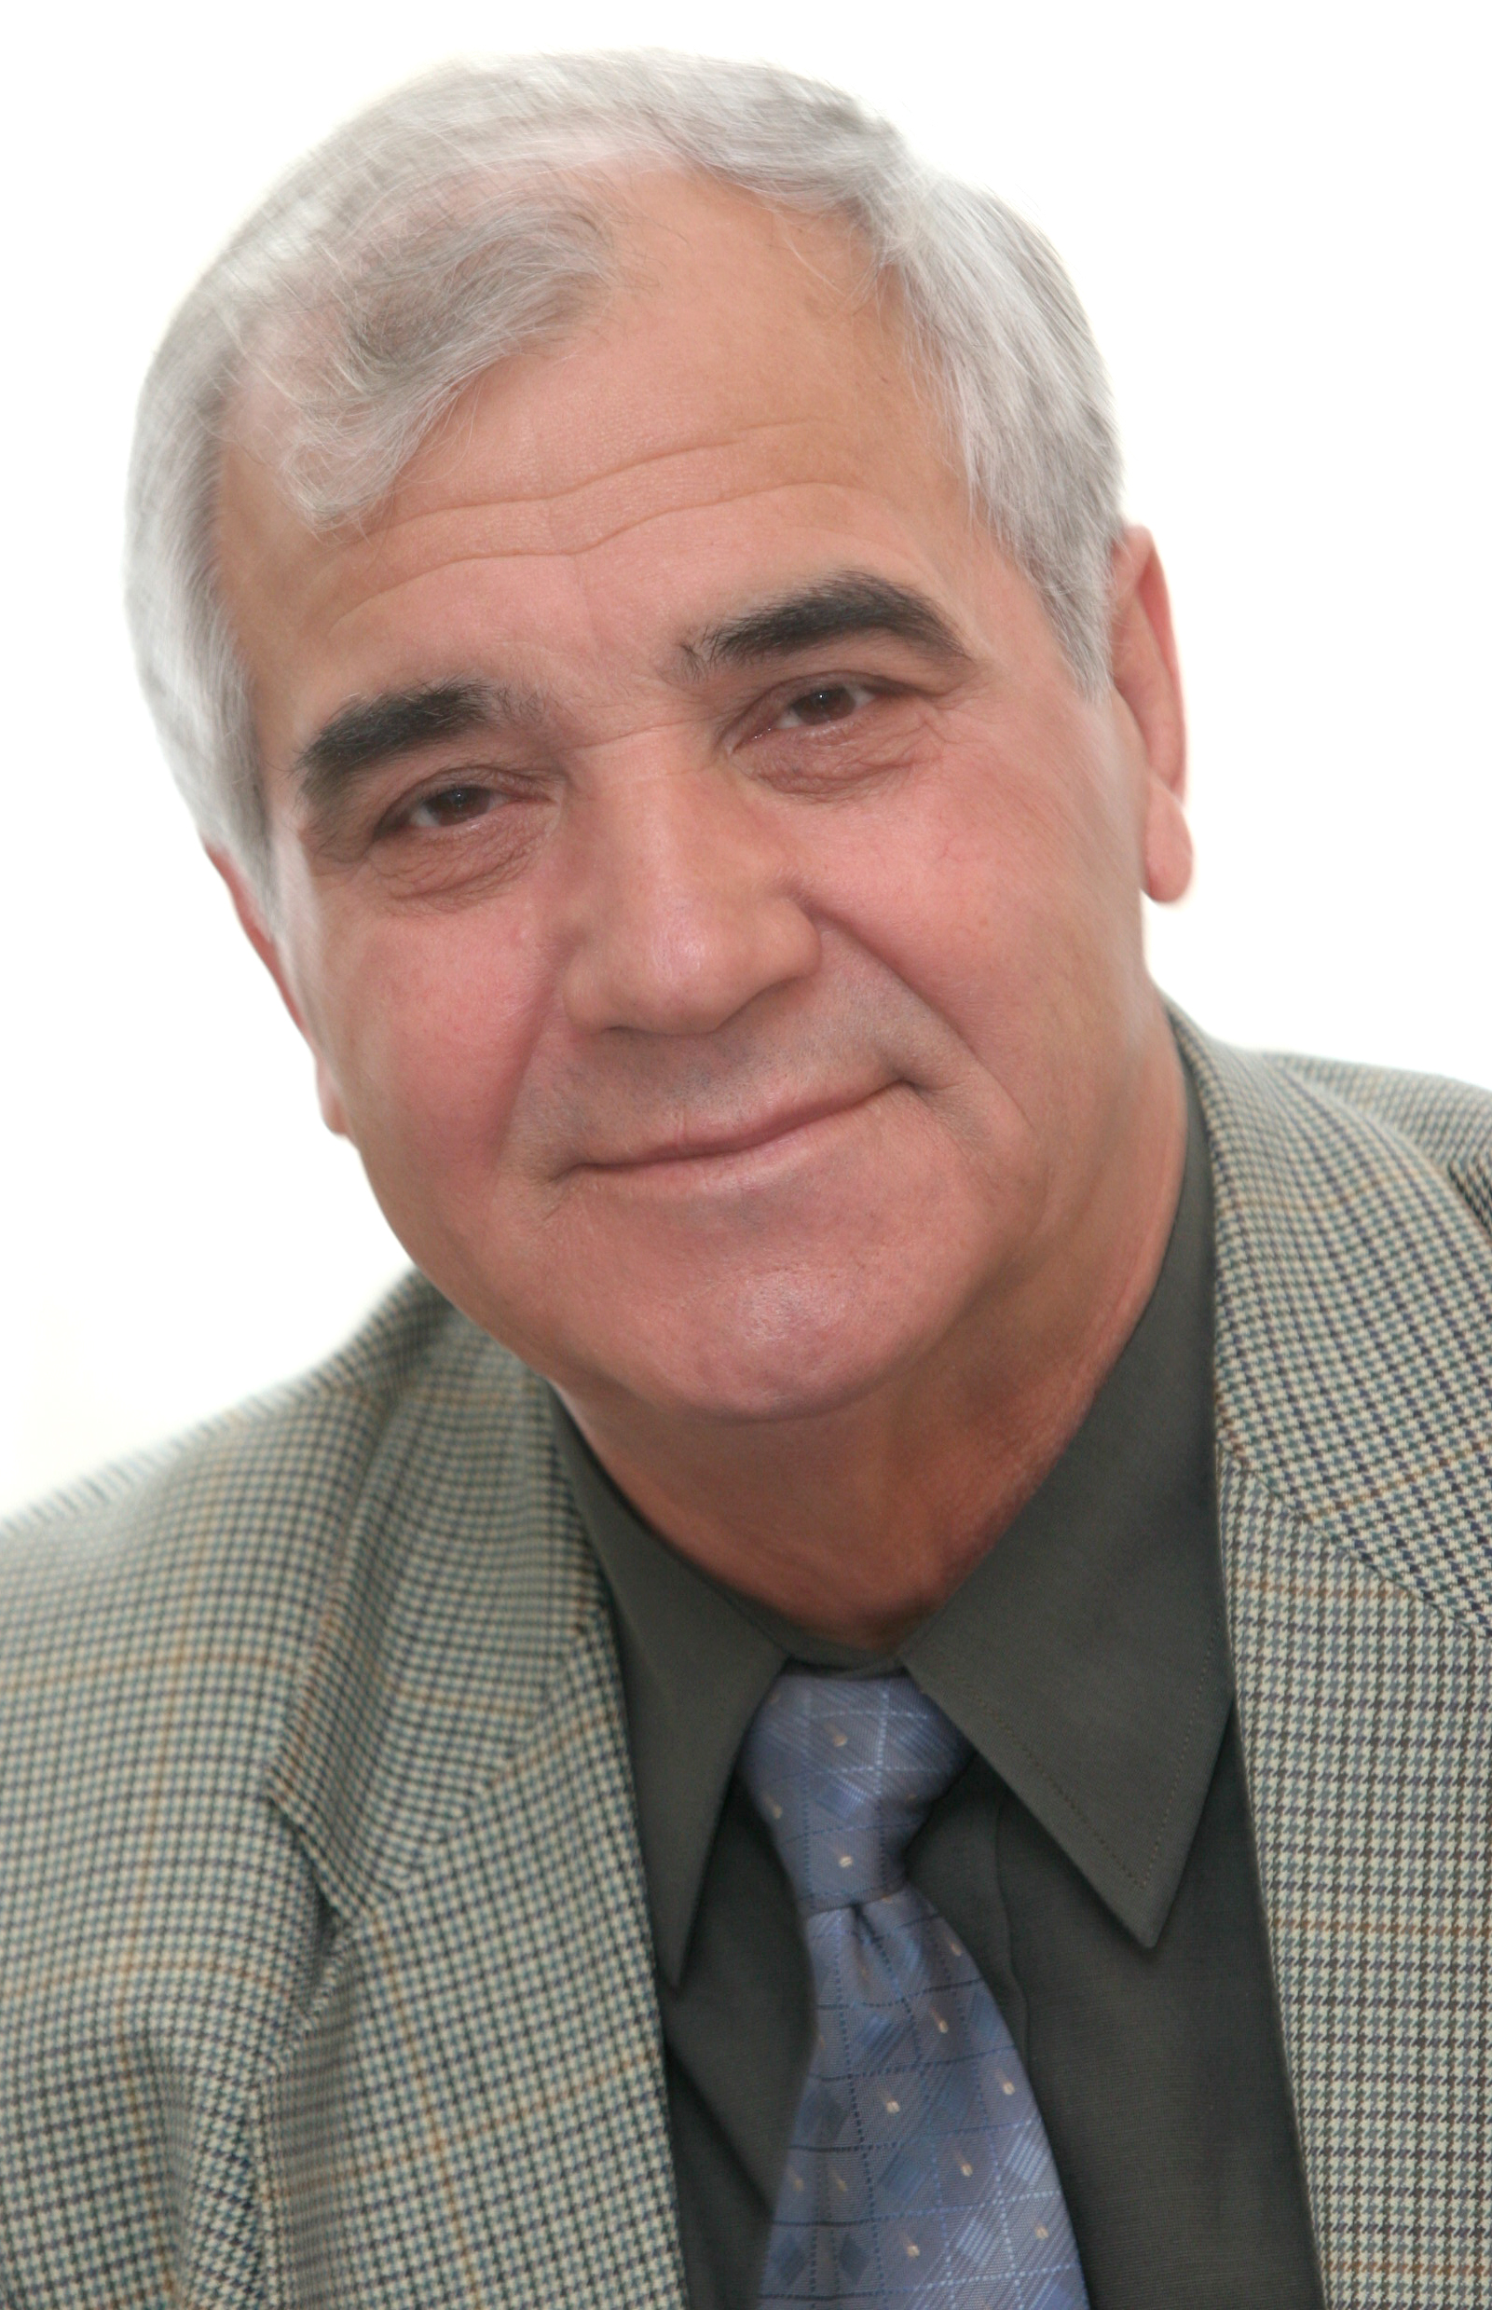
Born on October 5, 1940 in Zavet, Razgrad District. He graduated from the Sofia University St. Kliment Ohridsky, Major Law.
He worked as Chief Legal Adviser at the Construction and Machine Building Administration in Pleven. Chairperson of the Labour and Social Insurance Committee and Member of the Legislative Committee at the VII-th Grand National Assembly. Deputy Chairperson of the Central Election Committee.
He speaks Turkish.
Married, with a child.
The National Assembly elected him Member of the National Audit Office on November 24, 1995.
The National Assembly elected him for second time Member of the National Audit Office of the Republic of Bulgaria on April 13, 2005.

Kosta Kostov
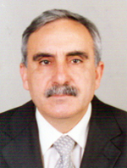
Born on January 2, 1946 in Orlov dol, Haskovo District.
He graduated in merchandising. Master of economy.
Before 1979 he has been head of economic departments in two companies in Sliven. From 1979 to 1992 is economic and trade manager of a glass factory in Sliven. From 1995 to 200 is expert in the local branch of First East International Bank - Sliven. From 200 to 2001 is economic manager of "Svicom" Plc.
Since 2001 he is a Member of Parliament in the 39th National Assembly where he is Chair of the Combating Corruption Committee, Member of the Budg et and Finance Committee and of the Agriculture and Forestry Committee.
He speaks Russian.
Married, with a daughter and a son.
The National Assembly elected him Member of the National Audit Office of the Republic of Bulgaria on April 13, 2005.

Lidia Roumenova (2009-2011)
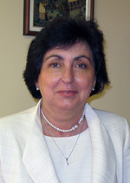
Born on November 27, 1953 in Selanovtsi, Vratsa district.
She graduated from the Sofia University St. Kliment Ohridsky - Major Law; Université Nancy 2 – France; Université Robert Schuman in Strasbourg - Major „Law of the European Union”.
She has rich practical experience in the field of civil and criminal law and legislation, tax and labour legislation, social and trade legal affairs, as well as in the field of communications.
Since 1978 she worked consecutively in the system of foreign trade as a legal advisor, for the National Committee of the Bulgarian women, at the Ministry of Labor and Social Services and the Ministry of Defense, and for the radio telecommunication company Mobikom.
Between 1981 and 1986 she worked as a prosecutor in the Prosecutor’s Office of the Republic of Bulgaria.
In the period 1986 - 1987 she worked as expert in the Council of Ministers.
Since 2005 until her appointment for member of BNAO she worked as Advisor to the Premier of the Republic of Bulgaria.
She is senior partner in INTEGRA Group Ltd. since 1997.
She is attorney-at-law, member of Sofia Bar Association and member of Council for European Affairs.
She holds quality control system certificate, certificate for safe and healthy conditions of the work process ISO 9000 and certificate „Legal actions and procedures before European courts”, Luxembourg 2008.
Fluent in English and Russian.
Married with two children.
The National Assembly elected her Member of the National Audit Office of the Republic of Bulgaria on May 28, 2009.

Snezhina Chipeva
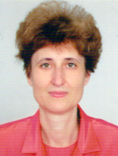
Born on October 16, 1951 in Sofia.
She graduated in Law from the Sofia University St. Kliment Ohridski, and in Foreign trade from the University of National and World Economy.
From 1980 to 1994 she has been successively Jurist and Head jurist in SOMAT "Chimcomplect Engineering" and "Chimimport" and member of the Supervision council of "Chimimport".
She is a lawyer in the Sofia town college since 1994.
Since 2001 she is a Member of Parliament. Member of the Legal Affairs Committee and the Economic Policy Committee.
She speaks French and German.
Married, with two children.
The National Assembly elected her Member of the National Audit Office of the Republic of Bulgaria on April 13, 2005.

Svilena Simeonova
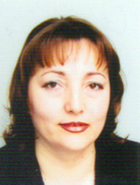
Born on December 4, 1958 in Bourgas.
She graduated in "Law" from the Sofia University St. Kliment Ohridski.
Since 1989 until now she is successively assistant, Senior assistant and Chief assistant in Financial Law, Administrative Law, Legal Administration of the Financial Control and Legal Base.
From 1997 to 2000 she is Chief Jurist and Head of the Legal Department in the Public Internal Financial Control Agency to the Ministry of Finance.
From 2000 to 2005 she is Head of the "Legal provision of the control activity and standards" Department to the Public Internal Financial Control Agency.
Since 2001 she is instructor of the Working Group 28 "Financial Control" in the accession negotiations of the Republic of Bulgaria to the European Union.
Member of the Coordination and Monitoring Council to the European Integration Council.
Member of the Institute of Internal Auditors, USA and Member of the Managerial Board of the International Committee of jurists.
Instructor and member of working groups on the bills of the Public Internal Financial Control Act, the Amendment of Public Internal Financial Control Act, the Public Procurement Act , the Amendment of the Penal Code.
She speaks English, French and Russian.
Married with a son.
The National Assembly elected her Member of the National Audit Office of the Republic of Bulgaria on April 13, 2005.

Roumiana Gueorguieva
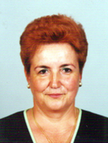
Born on September 18, 1951 in Plovdiv.
She graduated from the University of National and World Economy, Sofia, in "Foreign trade" and " Management and planning". She is an expert in the field of banking, financial analyses, combating fraud and corruption, supervision of banking and other financial institutions. From 1992 to 1996 she is a Chief expert in the Bank Consolidating Company and Executive Director of Teximbank. For several years she is a Managing director of "Special control" Department in the Bulgarian National Bank.
Since 2001 she is a Member of Parliament. She is a Member of the Budget and Finance Committee, Internal Security and Public Order Committee, Energy Committee, vice-representative of the Bulgarian delegation in the Parliamentary Assembly of the Organization for Security and co-operation in Europe.
She speaks English and Russian.
Married with two children.
The National Assembly elected her Member of the National Audit Office of the Republic of Bulgaria on April 13, 2005.

Valeri Apostolov
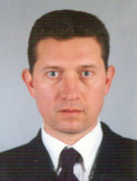
Born on December 1, 1964 in Kostinbrod. He graduated from the University of National and World Economy, Sofia and Varna Free University. Major in Economy and Management of Labor and in Law.
From 1991 to 2001 he is inspector and director in the regional administration "Social assurance" in Kardjali, managing director of Metropolitan bureau "Social assurance".
Since 2001 he is under secretary of Labor and Social Policy. He is manager of the "Labor circumstances" fund, member of the managerial councils of the State fund "Agriculture" and the program SAPARD, of the Development of Human Resources Center and of the Social Investments Fund. From 2002 to 2003 he is chairman of the Supervision council of the National institute for reconciliation and arbitration.
He has been the project manager of great number of international programs and projects, related to the social assurance field.
He has a certificate for international auditor of Secure labor circumstances management systems to MOODY INTERNATIONAL.
Certified internal auditor for the public sector by the Ministry of Finance.
Certified external evaluator of internal audit functions.
He specialized in assurance in UK, USA, Denmark, France, Spain, Chili and Argentina.
He is a lecturer in the University of National and World Economy.
He speaks English and Russian.
Married with two children.The National Assembly elected him Member of the National Audit Office of the Republic of Bulgaria on April 13, 2005.

